Day 28: SOC Dashboards and Reporting
// 26-28 | OVERVIEW & SCOPE

Day 28 shifts from detection engineering to making four weeks of lab telemetry usable. Two audiences are served: operations needs a live dashboard showing agent health and alert volume at a glance, and leadership needs a periodic summary of the overall threat picture. This phase draws on every prior workstream — Wazuh FIM and Windows Event Log alerting, Suricata IDS, pfSense-segmented network traffic, GeoIP/active-response blocking, and the VirusTotal/MITRE ATT&CK threat intel enrichment from Days 24-25 — and turns it into a dashboard and two written reports.

// 01 | CUSTOM WAZUH DASHBOARD

Built in the Wazuh dashboard builder against the Manager at 192.168.56.10, pulling from the win10-vm agent, Kali probe traffic, and Suricata/pfSense log sources. Five panels, arranged so severity and agent health are visible above the fold without scrolling:
• Total alert count, past 7 days, broken down by severity
• Agent health status — which agents are Active vs. not reporting
• Top 10 rules by alert count for the week
• Top source IP addresses generating alerts
• Geolocation map of source IPs (GeoIP data already in use from the Days 15-21 GeoIP blocking work)
Dashboard named "Hanzallah — Week 4" per the internship's weekly naming convention.

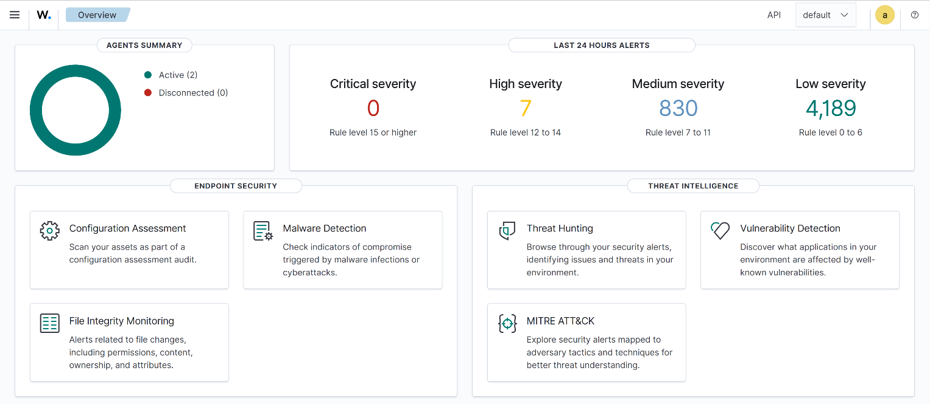

// 02 | WEEKLY SOC SUMMARY REPORT — TECHNICAL

Analyst: Muhammad Hanzallah | Mentor: Abdullah Zia | Reporting period covers Days 22-28.

$ Authentication Events
Coverage carries forward the Windows Event Log rules built earlier in the internship (Event IDs 4625 failed logon, 4720 account created, 4672 special privileges assigned) and the SSH brute-force detection (rule 5712, MITRE T1110) tied to active-response firewall-drop on the Wazuh Manager.
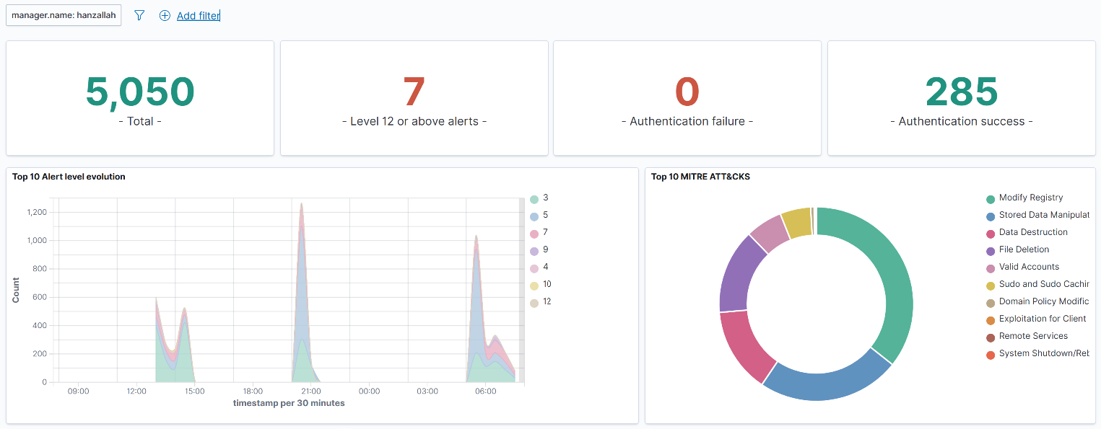

$ File Integrity Monitoring (FIM) Events
Syscheck coverage on win10-vm, enriched by VirusTotal on file-hash matches. The Days 24-25 fix — patching Wazuh 4.14.5's bundled virustotal.py from the deprecated v2 endpoint to v3 with x-apikey header auth — is what makes this enrichment functional; without it, FIM events generate no VirusTotal verdict at all, a visibility gap worth restating here if it recurs.
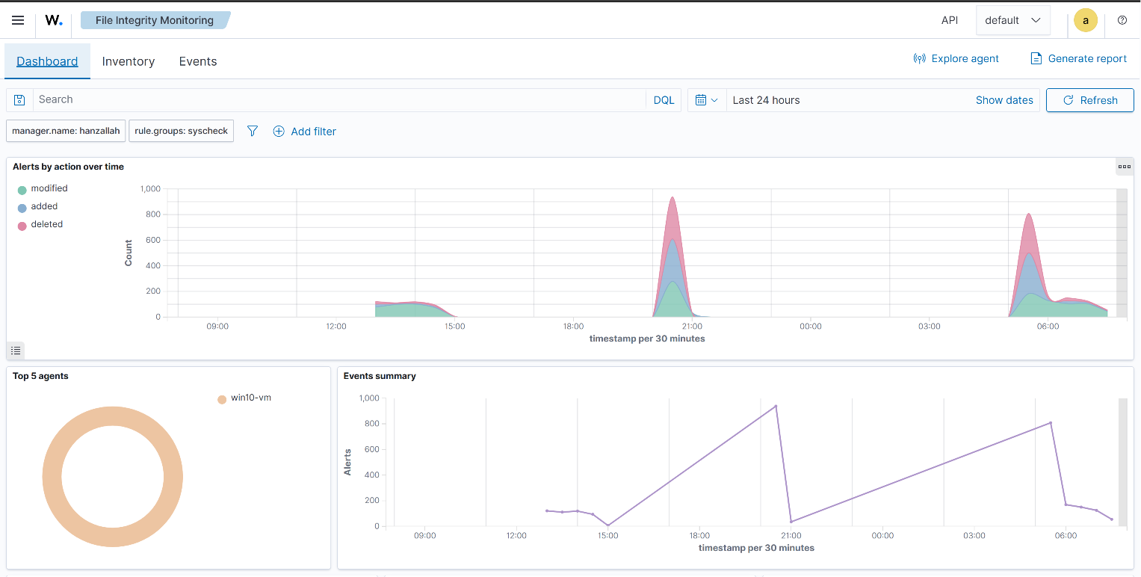
$ Network Events (Suricata)
Suricata running in af-packet mode with custom rules against traffic now routed through pfSense rather than the flat network used earlier in the internship.
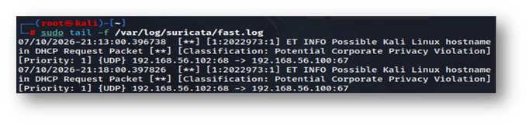
$ pfSense Firewall Events
The Days 22-23 network segmentation is now the baseline: pfSense sits between all lab VMs and the internet, with the Wazuh Manager, Kali, and win10-vm all pointed at it as their default gateway. Firewall log volume this week reflects that segmented topology rather than the pre-pfSense flat network, plus GeoIP-based blocking (ipset/iptables) carried over from Days 15-21.
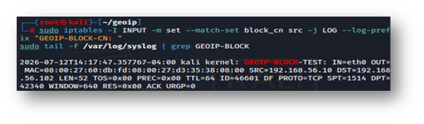
$ Threat Intelligence Hits
VirusTotal FIM enrichment (v3 endpoint), Abuse.ch/URLhaus CDB feed matches, and MITRE ATT&CK technique mapping from the Days 24-25 integration.
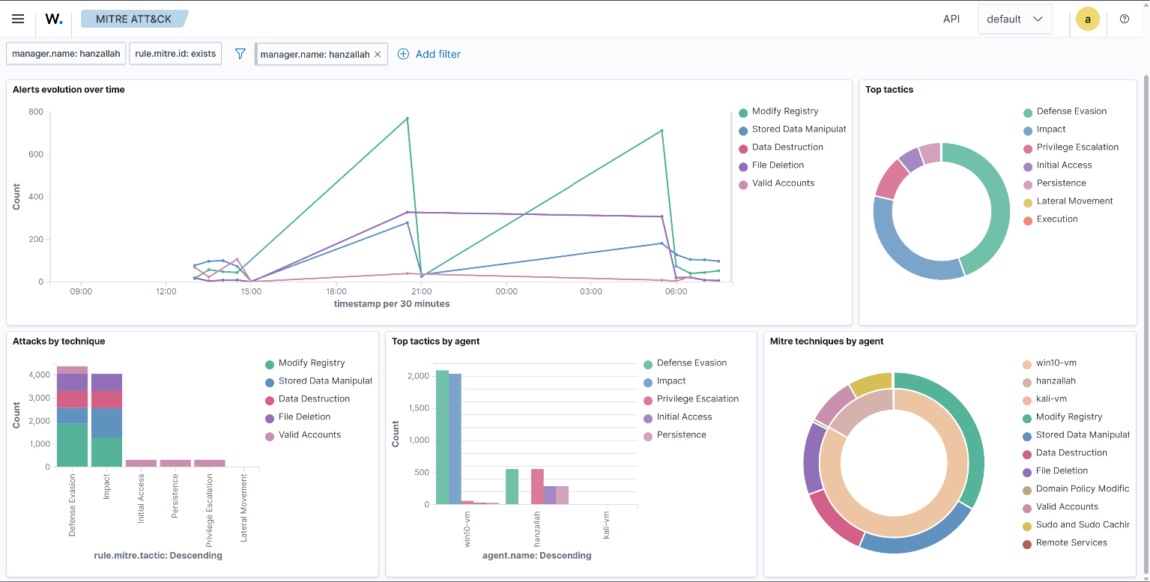

$ Summary
"Week 4 extended detection coverage into the network layer: pfSense's segmentation (Days 22-23) put a controlled chokepoint between every lab VM and the internet, and Suricata's af-packet monitoring now inspects traffic through that boundary rather than a flat network. Combined with the Days 24-25 VirusTotal v3 fix restoring FIM enrichment and the existing SSH brute-force/GeoIP active-response chain, the lab's detection stack moved from isolated point tools toward a coordinated pipeline — this week's dashboard and reporting work (Day 26-28) is what makes that pipeline's output actually reviewable. No unresolved infrastructure issues remain outstanding heading into next week."

Overall Risk Posture
The lab environment remained stable this week. No unresolved security issues are outstanding, and the network is now more tightly controlled than it was going into the week.
Key Findings
- We finished walling off the lab network behind a dedicated firewall (pfSense), so every device now has to pass through one controlled checkpoint instead of talking to each other freely. This closes off a lot of the ways an attacker could move sideways between machines if one were compromised.
- We fixed a gap in our malware-checking system: file changes were being monitored, but the tool that cross-checks them against VirusTotal (a service that flags known-malicious files) had silently stopped working due to an outdated connection method. It's now confirmed working again, so file-change alerts are backed by real threat data instead of going unchecked.
- We built a live dashboard and this reporting process so that security status — alert volume, which systems are being watched, what's triggering alerts — can be reviewed at a glance going forward instead of requiring a manual dig through logs.
Recommendation
No immediate action is needed. Recommend continuing weekly review of the new dashboard to catch any drop in monitoring coverage early, and treating this week's fixes (firewall segmentation, malware-check restoration) as the new baseline going forward.

